Writing Journal Topic - Quotation Analysis #1 – January 5, 2015:
“I have _______________________ over and over and over again.
And that is why I _________________________.” ~ Michael Jordan
- Copy the heading and the quotation with the blanks.
- Brainstorm ways to complete the statement given what you know about the speaker.
- Confirm the correct wording of the quotation when directed.
- Write a paragraph (7 sentences or more) of what the quotation means and how the statement applies to you and your life.

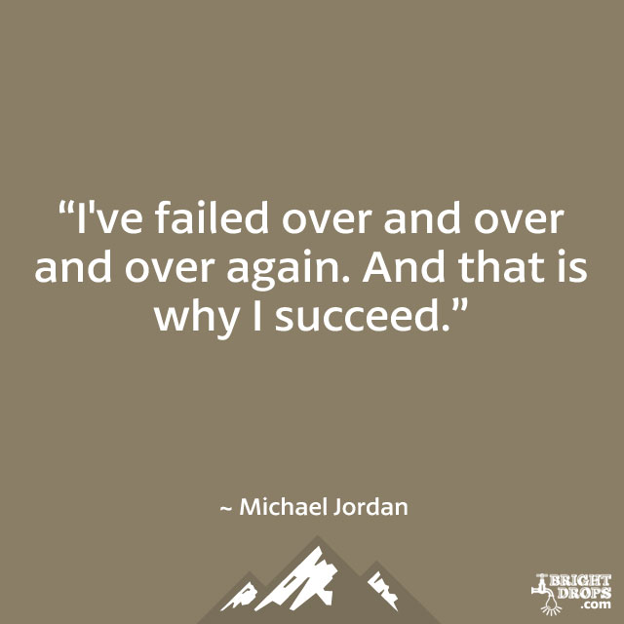

“I’ve failed over and over and over again. And that is why I succeed.” ~ Michael Jordan
Leave it to Michael Jordan to put into words a simple truth. You can’t succeed without failing because failing shows effort and shows that you’re attempting success. People who give up before they have reached their goals are gipping themselves of the chance to show dogged determination and perseverance. Failure teaches us what doesn’t work – not just what does. Most assuredly Michael Jordan missed plenty of shots in his lifetime of playing basketball; however, he tweaked his shot with each miss until he missed less and less. With each successful shot, he learned not to be afraid to take the shot, even if the entire game was riding on it. That fearlessness in the face of possible failure is something we can all take away. Personally, I need to remember this quotation as I train to run my first 5K race. Each day I must face the challenge of running a little faster and a little longer so I’ll be able to reach my goal. If a day goes by without progress, I cannot give up. Rather, I will need to try harder the next time so that by race day, I will succeed…in true Michael Jordan fashion!
  - Did you include introductory and concluding sentences?
If not, revise it.
  - Did you include any advanced vocabulary?
If so, highlight it. If not, revise it.
  - Did you explain the quotation in detailed sentences?
If not, revise it.
  - Did you relate the quotation to your own life?
If not, revise it.
  - Did you include one complex sentence?
If so, star it *****. If not, revise it.
  - Did you include any transitional words or phrases?
If so, underline them. If not, revise it.

(1)Leave it to Michael Jordan to put into words a simple truth. (2) You can’t succeed without failing because failing shows effort and shows that you’re attempting success. (3) People who give up before they have reached their goals are gipping themselves of the chance to show dogged determination and perseverance. (4) Failure teaches us what doesn’t work – not just what does. (5) Most assuredly Michael Jordan missed plenty of shots in his lifetime of playing basketball; however, he tweaked his shot with each miss until he missed less and less. (6) With each successful shot, he learned not to be afraid to take the shot, even if the entire game was riding on it. (7) That fearlessness in the face of possible failure is something we can all take away. (8) Personally, I need to remember this quotation as I train to run my first 5K race. (9) Each day I must face the challenge of running a little faster and a little longer so I’ll be able to reach my goal. (10) If a day goes by without progress, I cannot give up. (11) I will need to try harder the next time so that by race day, I will succeed…in true Michael Jordan fashion!
  - Did you include introductory and concluding sentences?
If not, revise it.
  - Did you explain the quotation in detailed sentences?
If not, revise it.
  - Did you relate the quotation to your own life?
If not, revise it.
  - Did you include at least one complex sentence?
If so, star it *****. If not, revise it.
  - Did you include any transitional words or phrases?
If so, underline them. If not, revise it.
  - Did you include any advanced vocabulary?
If so, highlight it. If not, revise it.

