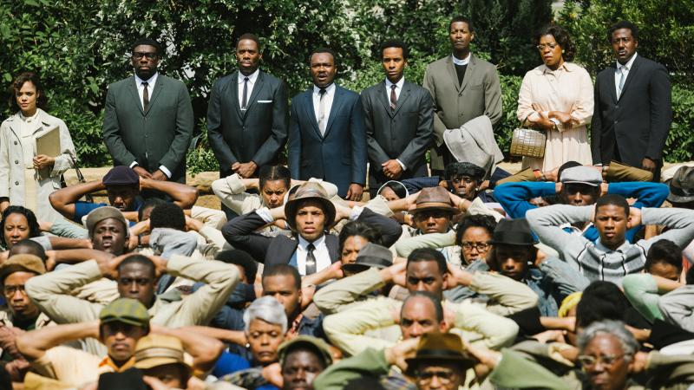SELMA – PG-13
The true story of Martin Luther King and the civil rights marches of Selma, Alabama, that changed America forever.
Starring: David Oyelowo, Carmen Ejogo, Tom Wilkinson, Wendell Pierce, Tim Roth, Oprah Winfrey
Genre: Drama
Release Year: 2014
Age 13+ Approved
Will Kids Like It? 4 out of 5 stars

Essential, Pertinent Cinema for Teens
by Tara McNamara
Mom, movie lover, tv personality, beach runner and sunset enthusiast
Selma is one of the most powerful pieces of cinema I’ve ever seen. I fully expect it will be soon be included as part of school curriculum and is a must-see for teens today.
Selma depicts the pinnacle moment of Martin Luther King Jr.’s fight for civil rights in a way that makes the audience feel like they’re going through it with him. Like last year's Jackie Robinson biopic 42, we are privy to the bravery King and his family must deal with in the face of ignorance, extreme racism and chilling death threats. The audience can also see how the cards were stacked against him in the political world and the challenges that faced him within the black community, such as Malcolm X.
Selma is a tremendous lesson in what it really means to have courage and to stand up for what you believe in.
In the case of MLK and his followers, courage means facing down those who oppose you. It means taking a beating. It means facing death. For that reason, it’s best suited for high schoolers who can better comprehend and process all that King and his followers were up against.
The film delves into King’s personal flaws – touching on extramarital affairs, seeing that he was a smoker (as many leaders were of that era), and occasionally self-doubt. Making sure we see our greatest leaders as humans rather than gods is important but, of course, it’s also important to discuss their foibles as well.
Selma is an ideal companion for a teen’s studies into American history. However, it’s also a primer for teens to understand what’s going on in our country right now. Parents need to take their teens to see Selma and then connect the dots between the King-led Selma march and the marches in Ferguson, New York, Berkeley and across the country that have been going on for the last month. Selma is essential.

Sex & Nudity
An audio recording of a man and woman having sex is played from a telephone in one scene.

Violence & Gore
Violent scenes of people being brutally mistreated, stomped, kicked, whipped, beaten with police batons, exposed to tear gas, and even murdered. Faces brutally swelled up, crying in pain, bleeding, etc..

Profanity
Infrequent use of words (except for racial slurs) including "s--," "bulls--t," "ass," and "goddamn." Much more frequent use of the "N" word and more.
2 uses of the F word.

Alcohol/Drugs/Smoking
One instance of a character smoking a cigarette.

Frightening/Intense Scenes
Multiple scenes that would be too frightening and intense for younger viewers not ready or mature enough to understand what was happening.

