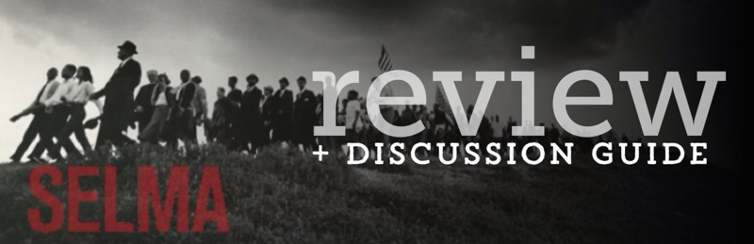One of the first scenes in director Ava DuVernay’s excellent thought-provoking film Selma will feel familiar to any youth worker. A group of young girls are chattering as they head down the stairs at Sixteenth Street Baptist Church on their way to Sunday school. The conversation about hairstyles offers the viewer a glimpse into the ordinary innocence of the moment. As the young adolescent girls head down the stairs, past a stained glass window of Jesus, the next moment rocks the audience, even those who know their history. The immediate and violent destruction of young lives in a typical church setting drives home the harsh reality of the Civil Rights Movement. The scene, while shot with a respectful and artistic eye, makes the point on a visceral level that violent injustice has no respect of age or gender. The fight for justice in the Deep South in the 1960s wasn’t just fought in halls of government, but in the streets and in the churches. It was not an intellectual exercise but one that came at the price of lives, even young lives.
In the film, Selma, the bombing in Birmingham in 1963 sets the stage for what’s to come in the next two years. DuVernay chooses to focus on one intensely charged political period and yet still gives the filmgoer a broad view of the complexity of the Civil Rights Movement.
Youth workers will understand on a unique level the scene that features a fierce debate about who should be the rightful leaders of the movement in Selma. Young adult activists, who had been laboring for voting rights in Selma since the previous summer, argue with seasoned veterans like Andrew Young (played by André Holland) and Dr. King (David Oyelowo) who appeared to be taking over the work. Although not portrayed in depth, we get a sense of the crucial roles that young leaders like Diane Nash (Tessa Thompson), James Bevel (Common) and John Lewis (Stephan James) played in fighting for justice as well as other young protestors who marched, bled and died for civil rights.
The real and bloody cost of standing up for what one believes is driven home by the scene where the protesters first attempt to cross Edmund Pettus Bridge. DuVernay vividly captures the tension and fear amidst the marchers as they courageously face the police. The second and third marches across Edmund Pettus Bridge give witness to the broad community that rose up in vivid response. Young and old, Black and White, pastors and lay people, Jews and Christians marched together for a cause they believed in.
Selma is an exceptional and relevant film that raises critical issues that inform us not only about our past, but also about our present. Its themes parallel current news stories to the point where in a one scene where David Oyelowo, playing a brilliant and nuanced Dr. King, is preaching at a funeral, the audience gasped, realizing that he could easily be preaching that same message in America today.

