Writing Journal Topic - Quotation Analysis #2 – January 13, 2015:
“I’d rather attempt to do _______________________________, than to attempt _____________________________.” ~ Robert H. Schuller
- Copy the heading and the quotation with the blanks.
- Brainstorm ways to complete the statement given what you know about the speaker.
- Confirm the correct wording of the quotation when directed.
- Write a paragraph (7 sentences or more) of what the quotation means and how the statement applies to you and your life.
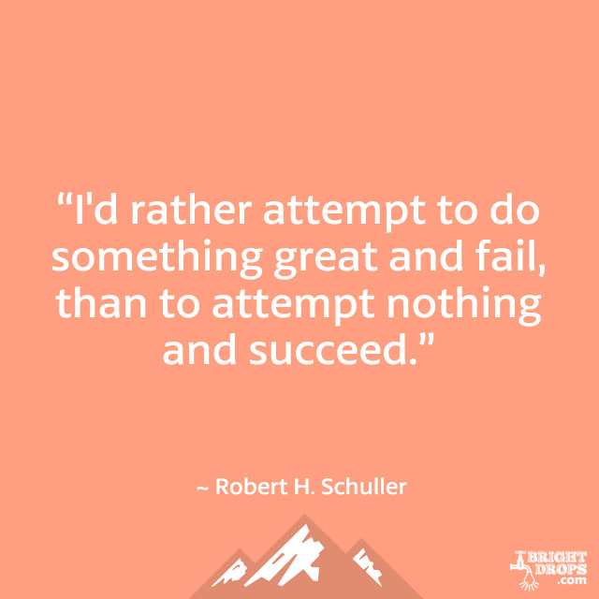
When Robert H. Schuller said, “I’d rather attempt to do something great and fail, than to attempt nothing and succeed,” he was speaking directly to teenagers. After all, the youth of today are our future, right? Our future depends upon people who work hard and try new things. It may sound simple, but nothing from nothing leaves nothing; therefore, it’s a better idea to try your hand at greatness. So what if you fail? At least you tried something amazing and have a story to tell. Those who attempt nothing, wind up with nothing to show for it and no story of even an attempt. How boring! I want to make sure that I am always striving for something great so that I can look back and say “I gave it a go.” Furthermore, if I have the right amount of perseverance, imagination, and a bit of luck, I might actually achieve something great for the history books.

  - Did you include introductory and concluding sentences?
If not, revise it.
  - Did you include any advanced vocabulary?
If so, highlight it. If not, revise it.
  - Did you explain the quotation in detailed sentences?
If not, revise it.
  - Did you relate the quotation to your own life?
If not, revise it.
  - Did you include one complex sentence?
If so, star it *****. If not, revise it.
  - Did you include any transitional words or phrases?
If so, underline them. If not, revise it.

