Meet Bretagne, the Last-Known Surviving Ground Zero Search Dog
By Kathy Ehrich Dowd 09/11/2014 AT 04:05 PM EDT
At Ground Zero in 2001, Bretagne was a specially trained 2-year-old golden retriever who had a sixth sense about who needed her most.
Thirteen years later, that sixth sense is as strong as ever.
The Texas-based canine, now 15, is believed to be the only surviving search dog who worked at the World Trade Center site following the 9/11 terrorist attacks – and her mission to help others continues.
"She still has this attitude of putting her paw up and saying, 'Put me in, coach!' She absolutely loves it!" her owner, Denise Corliss, tells Today.com. (She also spoke to Tom Brokaw for a segment that aired on the Today show Thursday morning.)
In September 2001, Corliss and Bretagne (pronounced "Brittany") traveled from their home in Texas to New York City – at their own expense and without pay – to assist responders desperately searching for survivors.
On the ground for her very first assignment, Bretagne's mission was twofold: search for potential survivors and comfort the men and women on the scene.
Ultimately, Bretagne could only find human remains – although her ability to console workers was something to behold.
Specifically, Corliss recalls a moment when Bretagne uncharacteristically left her side to seek out a sad-looking firefighter on the ground.
"I was surprised that she wasn't listening to me, but she really wasn't – it was like she was flipping me the paw," Corliss said. "She went right to that firefighter and laid down next to him and put her head on his lap."
This week, the pair returned to the World Trade Center site for the first time since their mission – which Corliss said brought back the emotion of their 13-year-old assignment.
"Seeing this kind of took my breath away a bit, similar to how the pile was the first time I saw it," Corliss said. "It's so calm and peaceful now, unlike the chaos of before."
(Technically, Bretagne is not the only dog who helped on 9/11 who is still alive. Today.com reports a 15-year-old English springer spaniel named Morgan assisted in Staten Island in the aftermath of the tragedy.)
In the years since 9/11, Corliss and Bretagne were on scene at other disasters, including Hurricane Katrina, Hurricane Rita and Hurricane Ivan.
At age 9, she retired from disaster work, but now uses her talents at a local elementary school, where she assists special-needs first graders who are learning to read aloud.
"I've seen Bretagne almost select a child," Shelley Swedlaw, a search dog handler and a onetime special education director who works with Bretagne at the school, told the site. "She's just really good about knowing who needs that kind, canine attention."

Last living 9/11 Ground Zero search dog returns to World Trade Center site

Bretagne, the golden retriever, was just 2 years old when she traveled with her handler to New York after the World Trade Center attacks. Today, the 15-year-old pooch is officially retired from rescue duties, but she still works as a service dog in elementary schools, helping special needs students learn to read.
BY Meg Wagner
NEW YORK DAILY NEWS
Published: Thursday, September 11, 2014, 11:36 AM
Updated: Thursday, September 11, 2014, 2:17 PM
A heroic dog is heading back to the site where she earned her superpup status.
Bretagne the golden retriever is the last surviving rescue dog who searched Ground Zero after the 9/11 terrorist attacks.
This week, the 15-year-old pooch returned to the Manhattan site for the first time since 2001, her fur now more white than golden. At her side was Denise Corliss, her longtime handler and owner.
"Seeing this kind of took my breath away a bit, similar to how the pile was the first time I saw it," Corliss, told the Today show. "It's so calm and peaceful now, unlike the chaos of before."
Bretagne and Corliss arrived in New York City about a week after the attack on the World Trade Center. The Texas-based duo was part of a group brought in to relieve the first wave of first responders from duty.
Bretagne was just 2 years old when she traveled to New York City with her owner, Denise Corliss, to search Ground Zero after the 9/11 terrorist attacks.
The rescue effort was Bretagne and Corliss' first together.
Corliss’ first taste of search and rescue came years before. Already part of a local disaster relief team, she volunteered to play a victim during a training drill.
Test organizers buried her in rubble so the pups could find her in a disaster simulation. She laid there for hours before she heard a dog sniffing around her. Soon, he was barking on top of her, telling the human rescue teams she was there.
“Even though it was a test situation, I remember feeling so relieved,” Corliss told the Daily News. “And I thought, ‘What must this really feel like to someone in a real situation?’ I wanted to give that feeling to other people.”
Corliss brought home the tawny puppy in 1999 and immediately began training her for search dog duties. Especially astute dog-handler pairs are selected to help federal teams during national emergencies.
In 2000, the two made it into the ranks of Texas Task Force 1, meaning they were officially cleared for national disaster duty.
During the 9/11 mission, the then-2-year-old Bretagne worked 12-hour days alongside about 300 other pooches.
Most nights, the teams were lucky if they got four hours of sleep, Corliss said.
When the rescue dogs weren't searching the rubble, they served as an impromptu therapy dogs for the human rescuers.
"You'd see firefighters sitting there, unanimated, stone-faced, no emotion, and then they'd see a dog and break out into a smile," Cindy Otto, a vet who cared for the dogs at Ground Zero, explained. "Those dogs brought the power of hope. They removed the gloom for just an instant."
Corliss said at one point Bretagne dashed from her side to tend to a morose firefighter. Even when Corliss ordered the well-trained dog to come back, Bretagne stayed by his side.
"It was like she was flipping me the paw," Corliss said. "She went right to that firefighter and laid down next to him and put her head on his lap."
Read more: http://www.nydailynews.com/new-york/living-9-11-ground-zero-search-dog-returns-site-article-1.1936151#ixzz3DQo4PlRt

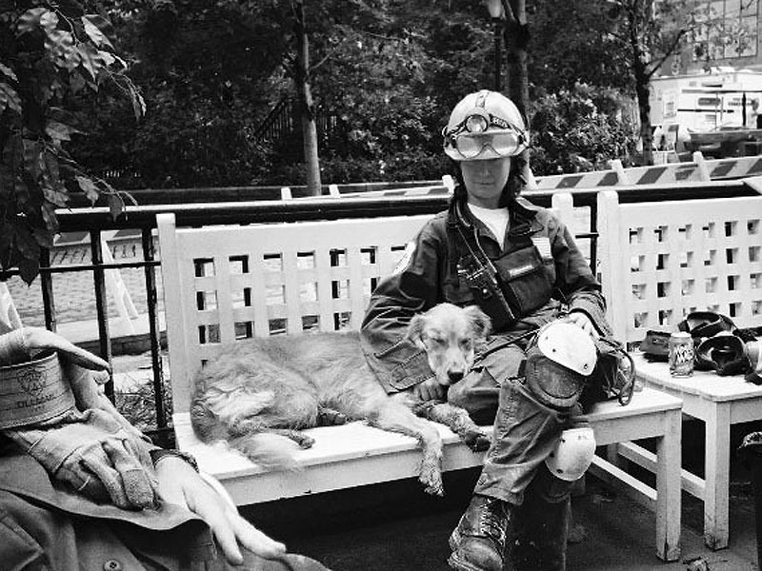
Bretagne resting with owner Denise Corliss near Ground Zero in Sept. 2001
Blake Wallis / Barcroft USA / Getty

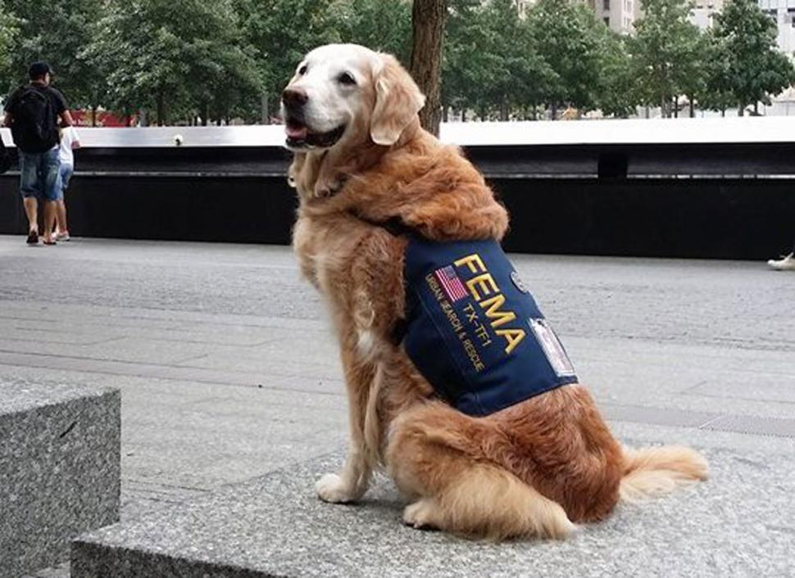Texas Task Force 1 via Facebook Bretagne, the last living Ground Zero search dog, visited the former World Trade Center site ahead of the 13th anniversary of the 9/11 attacks.
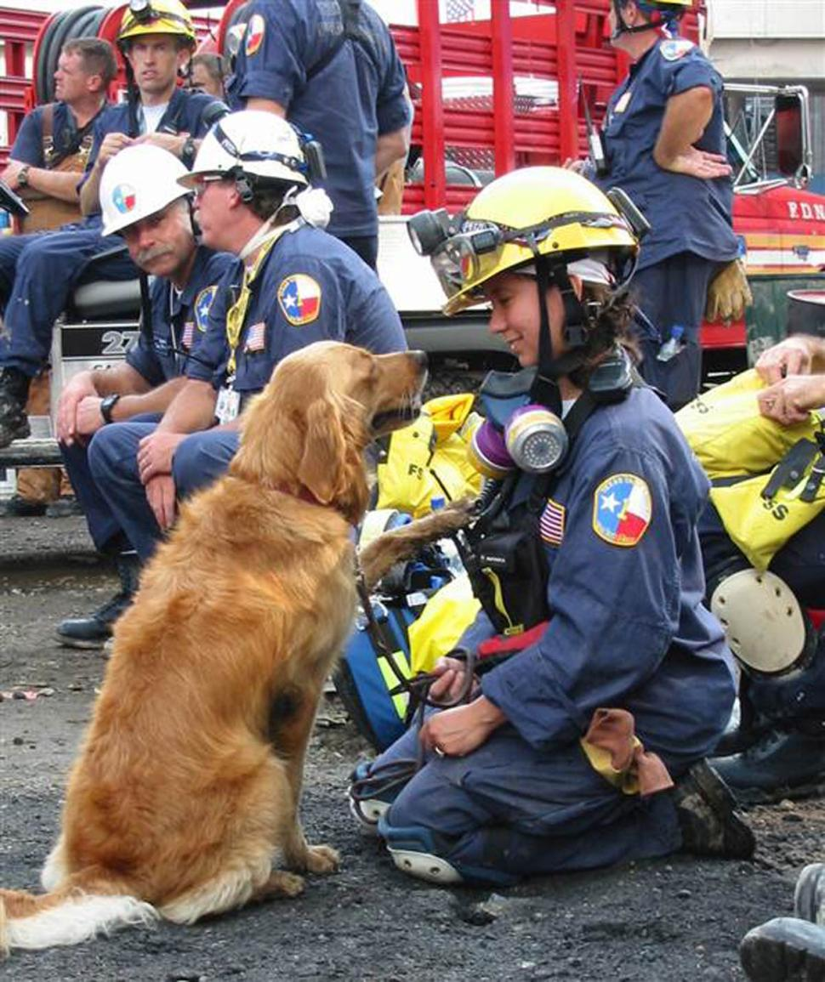Courtesy Denise Corliss Enlarge 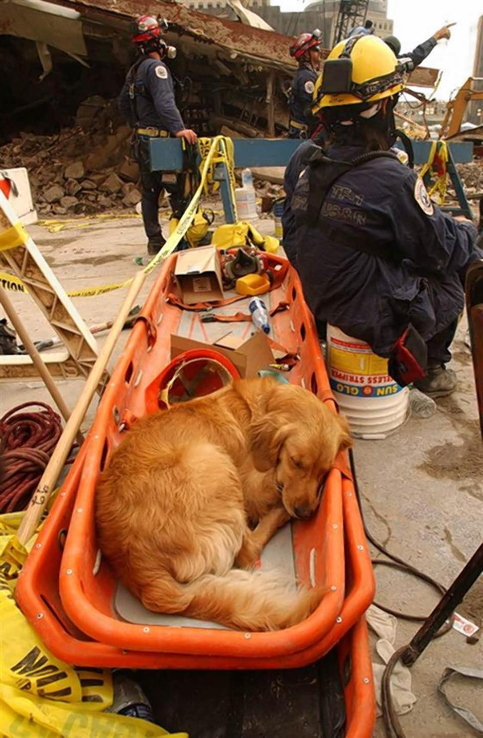Andrea Booher/FEMA Enlarge
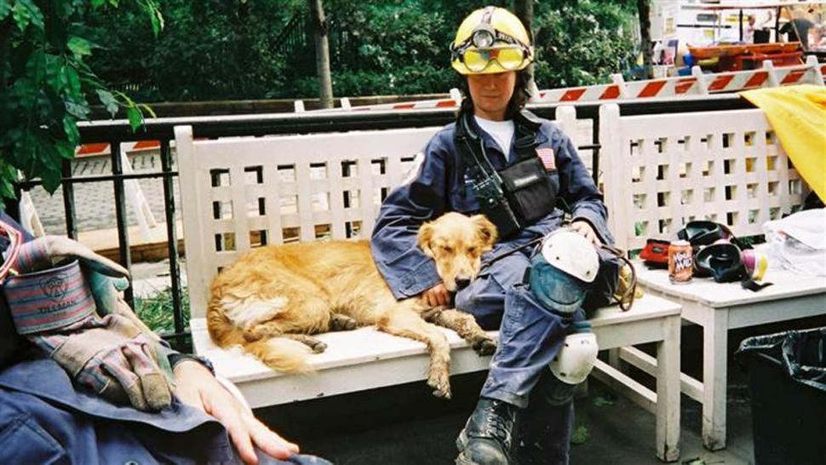Courtesy Denise Corliss The 9/11 mission with Corliss and Bretagne's first together. They spent ten 12-hours a day on the pile.
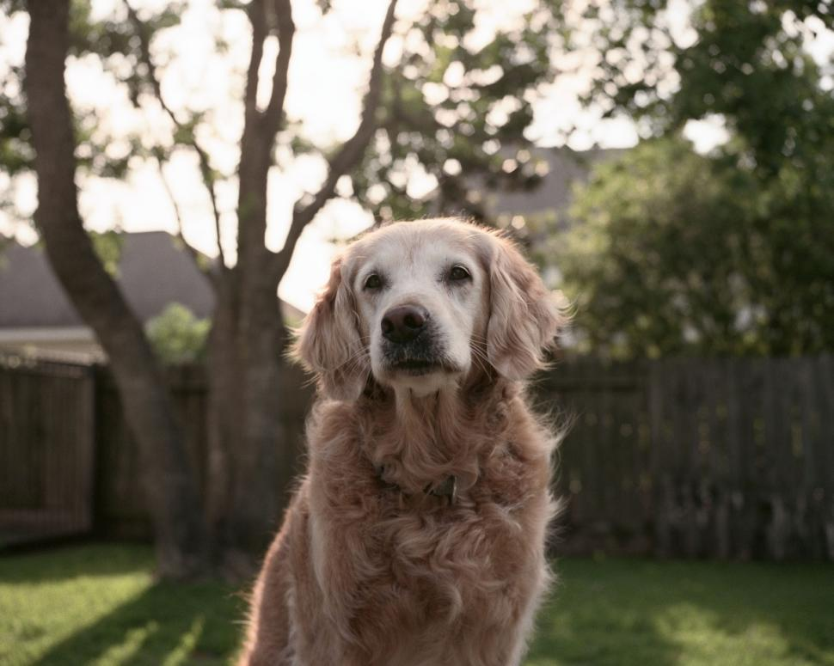Barcroft Media/Barcroft Media via Getty Images Bretagne, from Texas, is retired from rescue duties but still volunteers as a therapy dog in local schools.

